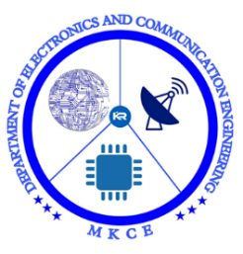

A Minor Project Report

On

**WIFI DOOR LOCK SYSTEM USING ESP32 CAM**

Submitted in partial fulfilment of requirements for the award of the

Degree of

**BACHELOR OF ENGINEERING**

in

**ELECTRONICS AND COMMUNICATION ENGINEERING**

Under the guidance of

**Mr L. RAMESH**

**Submitted By**

KARNIKASHREE C (927621BEC071)

**DEPARTMENTOF ELECTRONICS AND COMMUNICATION ENGINEERING**

**M.KUMARASAMY COLLEGE OF ENGINEERING**

(Autonomous)

**KARUR – 639 113**

NOVEMBER 2022

**M.KUMARASAMY COLLEGE OF ENGINEERING, KARUR**

**BONAFIDE CERTIFICATE**

Certified that this project report " WIFI DOOR LOCK SYSTEM USING ESP32 CAM" is the bonafide work of " JANANI K(927621BEC066), KARNIKASHREE C(927621BEC071), KESAVI R(21BEC087), LAKSHANA K(927621BEC099)" who carried out the project work under my supervision in the academic year 2021-2022

.

**SIGNATURE SIGNATURE** DR.S.PALANIVEL RAJAN M.E.,PH.D.,D.LITT (USA)., Mr.L.RAMESH, M.E.

**HEAD OF THE DEPARTMENT SUPERVISOR**

ASSOCIATE PROFESSOR ASSISTANT PROFESSOR

Department of Electronics and Department of Electronics and

Communication Engineering, Communication Engineering,

M.Kumarasamy College of Engineering, M.Kumarasamy College of Engineering,

Thalavapalayam, Karur-639113. Thalavapalayam, Karur-639113.

This project report has been submitted for the **18ECP103L- Minor Project I** Viva Voce

Examination held at M.Kumarasamy College of Engineering, Karur on ______________.

**Vision and Mission of the Institute and Department**

**Vision**

To emerge as a leader among the top institutions in the field of technical education.

**Mission**

* Produce smart technocrats with empirical knowledge who can surmount the global challenges.
* Create a diverse, fully-engaged, learner-centric campus environment to provide quality education to the students.
* Maintain mutually beneficial partnerships with our alumni, industry and professional associations.

**Department of Electronics and Communication Engineering**

### **Vision**

To empower the Electronics and Communication Engineering students with emerging technologies, professionalism, innovative research and social responsibility.

### **Mission**

* Attain the academic excellence through innovative teaching learning process, research areas & laboratories and Consultancy projects.
* Inculcate the students in problem solving and lifelong learning ability.
* Provide entrepreneurial skills and leadership qualities.
* Render the technical knowledge and skills of faculty members.

**PROGRAM EDUCATIONAL OBJECTIVES (PEO'S)**

* **PEO1:** Graduates will have a successful career in academia or industry associated with electronics and communication engineering.
* **PEO2:** Graduates will provide feasible solutions for the challenging problems through comprehensive research and innovation in the allied areas of electronics and communication engineering.
* **PEO3:** Graduates will contribute to the social needs through lifelong learning, practicing professional ethics and leadership quality

**PROGRAM OUTCOMES(PO'S)**

* **PO1: Engineering knowledge:** Apply the knowledge of mathematics, science, engineering fundamentals, and an engineering specialization to the solution of complex engineering problems
* **PO2: Problem analysis:** Identify, formulate, review research literature, and analyze complex engineering problems reaching substantiated conclusions using first principles of mathematics, natural sciences, and engineering sciences
* **PO3: Design/development of solutions:** Design solutions for complex engineering problems and design system components or processes that meet the specified needs with appropriate consideration for the public health and safety, and the cultural, societal, and environmental considerations
* **PO4: Conduct investigations of complex problems:** Use research-based knowledge and research methods including design of experiments, analysis and interpretation of data, and synthesis of the information to provide valid conclusions
* **PO5: Modern tool usage:** Create, select, and apply appropriate techniques, resources, and modern engineering and IT tools including prediction and modeling to complex engineering activities with an understanding of the limitations
* **PO6: The engineer and society:** Apply reasoning informed by the contextual knowledge to assess societal, health, safety, legal and cultural issues and the consequent responsibilities relevant to the professional engineering practice
* **PO7: Environment and sustainability:**Understand the impact of the professional engineering solutions in societal and environmental contexts, and demonstrate the knowledge of, and need for sustainable development
* **PO8: Ethics :**Apply ethical principles and commit to professional ethics and responsibilities and norms of the engineering practice
* **PO9: Individual and team work:** Function effectively as an individual, and as a member or leader in diverse teams, and in multidisciplinary settings
* **PO10: Communication:** Communicate effectively on complex engineering activities with the engineering community and with society at large, such as, being able to comprehend and write effective reports and design documentation, make effective presentations, and give and receive clear instructions
* **PO11: Project management and finance:** Demonstrate knowledge and understanding of the engineering and management principles and apply these to one’s own work, as a member and leader in a team, to manage projects and in multidisciplinary environments
* **PO12: Life-long learning:** Recognize the need for, and have the preparation and ability to engage in independent and life-long learning in the broadest context of technological change.

**PROGRAM SPECIFIC OUTCOMES(PSO'S)**

* **PSO1**: Applying knowledge in various areas, like Electronics, Communications, Signal processing, VLSI, Embedded systems etc., in the design and implementation of Engineering application.
* **PSO2**: Able to solve complex problems in Electronics and Communication Engineering with analytical and managerial skills either independently or in team using latest hardware and software tools to fulfil the industrial expectations**.**

.

**Table of Contents**

|  |  |  |
| --- | --- | --- |
| **S.No.** | **Particulars** | **Page No.** |

vision and mission of the institution and department 3

POs, PSOs of the department 4

Mapping of project with POs and PSOs 5

List of figures 7

List of Tables 8

Abstract 9

1 Introduction 10

8 Literature survey 11

**List of Figures**

|  |  |  |
| --- | --- | --- |
| **Figure No** | **Figure Name** | **Page No** |

**Acronyms/List of Abbreviations**

**Acronym Abbreviations**

**ABSTRACT**

In terms of house security, the door is crucial. To keep the residence secure, the owner will keep the door locked at all times. However, owing to a rush when leaving the house, the house owner may forget to lock the door, or they may be unsure if they have closed the door or not. In this paper, we have presented a smart Wi-Fi Door Lock using the ESP32 CAM and the MIT App. In this simple working model, when a person hits the doorbell, the owner receives a notification on his/her phone with a photo of that person. The owner can also unlock the door from a mobile phone after checking the photo. The proposed Door Security System application Door Lock with ESP32 and Internet of Things (IoT) technology to monitor the status of the door, manage the door, and increase security in a home. MIT is a communication protocol that connects a smartphone to a door lock system and is used to increase the security of a home. Door plays an important role in home security. To secure the house, the occupants of the house will always have the door locked. However, sometimes the house occupants forget to lock the door due to hurry when leaving the house, or they may doubt whether they have locked the door or not. We propose an application called Door Security System which is based on Android using Internet of Things (IoT) technology to monitor the status of the door, controlling the door and increasing security in a house. MQTT cloud is utilized as the communication protocol between smartphone and door lock system.

**Keywords:** ESP32 CAM AI Thinker, Electric Lock , Wi-Fi , MIT app, Relay, Button.

**1. INTRODUCTION:**

Require a physical key to operate, instead relying on pins, passwords, Face ID, Radio-Frequency Identification (RFID), and other methods .Nowadays, everyone is concerned about security, whether it's data security or home safety. As IoT usage has grown and technology has improved, digital door locks have become quite common in recent years. We have previously developed a number of digital door lock applications by utilizing these various technologies. In this article, we will use the Espressif Systems' Camera (ESP32 CAM) to develop an IoT-based Wi-Fi Door Lock system .A low-cost development board with a micro-SD card port and a small Omni Vision OV2640 camera is the AI-Thinker ESP32-CAM module .It has a 7-stage pipeline architecture, two high-performance 32-bit LX6 CPUs, and a built-in Wi-Fi ESP32 S processor. The Door Security System application monitors the door's status using Internet of Things (IoT) technology and ESP32 CAM.A smart phone and a door lock system communicate with one another using the MIT companion communication protocol. You can use the Door Security System on both Android and iOS.

**2. LITERATURE SURVEY**

# **2.1** [**Meera Mathew**](https://ieeexplore.ieee.org/author/37086227902) **et al proposed “Super secure door lock system for critical zones “IEEE TRANSACTIONS ON INFORMATION FORENSICS AND SECURITY – 2018**.

The three methods listed above are significantly superior to the others in this method, which is based on an examination of various door lock access control mechanisms. Additionally, these three approaches complement one another to create a more robust system .Microcontroller PIC16F877A is utilized here which is a programmable gadget.

# **2.2** [**Muhammad Waseem**](https://ieeexplore.ieee.org/author/37088553262) **et al proposed “Face Recognition for Smart Door Lock System using Hierarchical Network “IEEE TRANSACTIONS ON INFORMATION FORENSICS AND SECURITY – 2020.**

Face Net is used in conjunction with a discriminative learning strategy in the current system's two-tier hierarchical network (HN) architecture for face recognition. We also built a prototype that works with multiple modes of recognition, like embedded system recognition followed by email authorization from the homeowner. The system consequently reduces the likelihood of false positives in this manner. In addition, the implemented embedded system concludes the proposed study.

# **2.3** [**Muhammad Azamuddin Zamri**](https://ieeexplore.ieee.org/author/37088966231) **et al proposed “Password Based Security Lock System “IEEE TRANSACTIONS ON INFORMATION FORENSICS AND SECURITY – 2021.**

The Password Based Door Lock System with the 8051 Microcontroller is a straightforward project that unlocks the door with a safe password. The use of mechanical lock-and-key systems is being phased out in favor of more cutting-edge locking mechanisms. Combining mechanical and electronic devices, these strategies are extremely clever. Two of the most obvious benefits of these one-of-a-kind lock systems are their simplicity and high efficiency .An electronic control gathering controls the result load by means of a secret key in such a programmed lock system. The output load can be a lamp, a motor, or any other mechanical or electrical load. This system shows a password-based door lock system that works with an 8051 microcontroller. When the right code or password is entered, the door unlocks and the person in question can enter the secured area. If someone else arrives, it will once more ask you to enter the password. The person will be denied access if the password is incorrect because the door will continue to close. In this kind of automatic lock system, a password is used to control the output load by an electronic control assembly. The output load can be a lamp, a motor, or any other mechanical or electrical load.

**3.SYSTEM DESIGN**

**3.1 PROPOSED SYSTEM**

The concept of an ESP32 CAM-based Wi-Fi door lock has recently emerged as a significant topic in home appliances. In this day and age, personal safety as well as data security are of the utmost importance. As IoT usage has grown and technology has improved, digital door locks have become quite common in recent years. Door Lock, an application for the proposed Door Security System that makes use of the Internet of Things (IoT) and ESP32 to manage doors and improve home security. MIT is a communication protocol that increases a home's security by connecting a smartphone to a door lock system. A low-cost development board with a micro-SD card port and a small OV2640 camera is the AI-Thinker ESP32 CAM module. It has two high-performance 32-bit LX6 CPUs, a 7-stage pipeline architecture, and an integrated Bluetooth and Wi-Fi chip. We developed an IOT-based Door Lock System with an Electric Lock and Relay module by utilizing the ESP32 CAM and MIT.

**3.2 TOOLS USED**

**Hardware requirements:**

1. Button
2. 12V Electric Lock
3. Driver
4. Relay
5. FTDI232 USB
6. ESP 32 CAM Module

**Software requirements:**

1. Arduino IDE

**POWER SUPPLY:**

The term "power supply" refers to an electrical power source. A power supply unit, or PSU, is a device or system that delivers electrical or other energy to an output load or group of loads. The term is typically used to refer to electrical energy sources, mechanical energy sources less frequently, and other sources less frequently.

The two main types of power supplies used in electronic devices are switching and linear. For high-current devices, the linear supply becomes increasingly heavy and bulky, despite its relatively straightforward design. In a linear supply, voltage regulation can reduce efficiency. A switched-mode supply with the same rating as a linear supply will be more complicated, smaller, and typically more energy efficient.

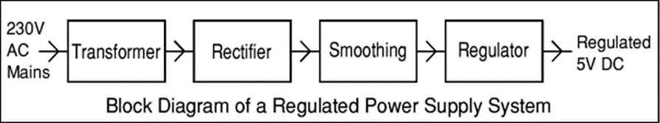

**Figure No: 3.1 Power Supply**

**DRIVER / RELAY MODULE**

* The driver relay circuit is connected with the digital pins of the micro controller & dc motors will be directly interfaced with the relay module
* According to the pre-loaded code, the controller will send a signal to driver/ relay circuit (ON / OFF). When the driver/ relay circuit gets ON condition the motor will be turned on using 12 volt dc supply
* The connection made with the motor and relay module is shown as below
* The red colour wire denotes the + ve supply, black colour wire denotes the – ve supply and the yellow colour wire mentioned in the diagram will get the output signal sent from the controller to turn on and of the relay
* In relay module there is 3 pins such as normally open/ normally closed and COM
* COM is directly supplied with 12 volt supply
* One terminal of the motor will be connected with the COM pin and the other terminal will be connected with ground
* Initially NC and COM will be connected together in the relay module
* When the relay module get a signal from the controller the connection will set to NO and COM and then the motor can be turned ON
* unless the motor will be in OFF condition
* Once the relay get OFF condition from the controller the connection between the NO and COM will be triggered OFF and the motor will be turned OFF

### 

### **Figure. No: 3.2 Relay operation using Darlington Pair**

When the base terminal of the NPN transistor is grounded (0 volts), zero current flows into the base therefore Ib = 0.

As the base terminal is grounded, no current flows from the collector to the emitter terminals therefore the non-conducting NPN transistor is switched “OFF” (cut-off).

If we now forward biased the base terminal with respect to the emitter by using a voltage source greater than 0.7 volts, transistor action occurs causing in a much larger current to flow through the transistor between its collector and emitter terminals.

The transistor is now said to be switched “ON” (conducting).

If we operate the transistor between these two modes of cut-off and conduction, the transistor can be made to operate as an electronic switch.

Thus, by this operation we can operate the transistor as a switch to ON and OFF the motor with the help of relay.

### **REGULATOR**

### The output voltages of voltage regulator integrated circuits can be either fixed (typically 5, 12, or 15V) or variable. They are also rated based on their capacity to carry a maximum current. There are negative voltage regulators available, primarily for dual supply applications.

Overload protection (also known as "thermal protection") and overheating are two types of automatic protection that are present in the majority of regulators.

The LM78XX series of three terminal regulators is available with several fixed output voltages making them useful in a wide range of applications. One of these is local on card regulation, eliminating the distribution problems associated with single point regulation. The voltages available allow these regulators to be used in logic systems, instrumentation, HiFi, and other solid state electronic equipment. Although designed primarily as fixed voltage regulators these devices can be used with external components to obtain adjustable voltages and currentMany of the fixed voltage regulator ICs has 3 leads and look like power transistors, such as the 7805 +5V 1A regulator shown on the right. They include a hole for attaching a [**heat sink**](http://www.kpsec.freeuk.com/components/heatsink.htm) if necessary.

1. Positive regulator
   1. input pin
   2. ground pin
   3. output pin

It regulates the positive voltage

1. Negative regulator
   1. ground pin
   2. input pin
   3. output pin

It regulate the negative voltage

**ESP32 CAM MODULE**

ESP32-CAM, the latest small-size camera module released by Essence. This component can easily work separately due to its tiniest design with a size of 27*40.5mm and wide sleep current as low as 6mA. ESP32-CAM is usually widely utilized in various IoT applications, suitable for home smart devices, industrial wireless control, wireless monitoring, QR wireless identification, wireless positioning system signals and other IoT applications. It's a perfect solution for IoT applications. ESP32-CAM adopts DIP package and should be used directly by plugging within rock bottom plate, realizing the rapid production of products, providing customers with high-reliability connection methods, which is useful for various application in IoT hardware terminal occasions.

The AI-Thinker ESP32-CAM module is a low-cost development board with a micro-SD card port and a small (Omni Vision’s)OV2640 camera. It has a built-in Wi-Fi ESP32 S processor with two high-performance 32-bit LX6 CPUs and a 7-stage pipeline architecture.

There are 4 pins only connected to the FTDI232 converter. TX to RX,RX to TX and 5V and GND. Then GPIO 0 to GND Must be shorted.

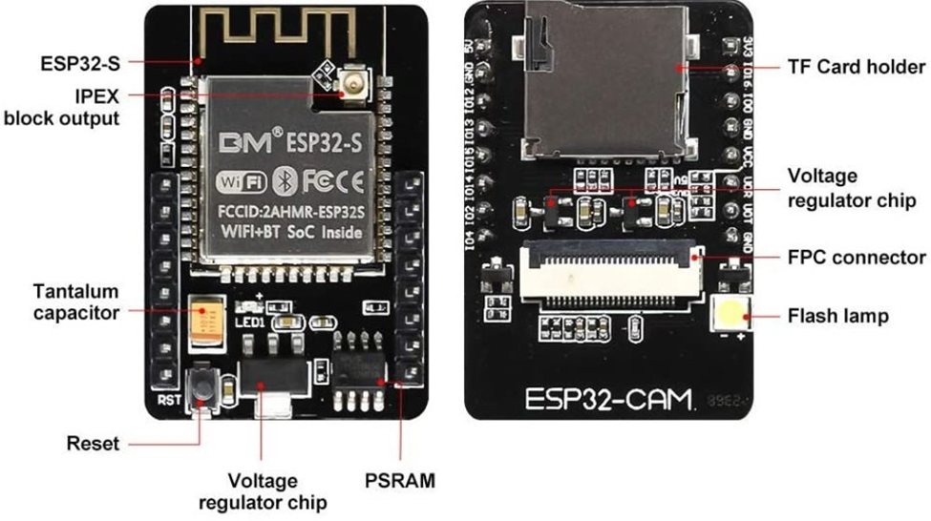

**Figure .No: 3.3 ESP32 CAM**

**ESP32-S** **Chip**: The module is a main chip contains two high-performance 32-bit LX6 CPUs with a 7-stage pipeline architecture and used for all the processing and functioning.

**IPEX block output**: The printed IPEX connects GSM antennas to transmit signals.

**Tantalum capacitor**: The tantalum capacitor is majorly used on small size modules. They are durable and provide power supply filtering for fine signal quantity.

**Reset button**: When pressed, the reset button restarts the code executed on the module.

**Voltage regulator chip**: The voltage regulator chip on the module maintains the output voltage despite the fluctuations in the input supply. It regulates the voltage to 3.3 volts.

**PSRAM**: A low-power Pseudo-Random Access Memory of 4MB is incorporated in the module for fast processing of the instructions. It helps the camera to run smoothly.

**TF Card Holder**: ESP32 series are embedded with a micro-SD card holder to store the data. All the transmission takes place through the Serial Peripheral Interface.

**FPC connector**: To mount the camera, the ESP32 module contains a flexible printed circuit connector. Their fine pitch is responsible for signal reliability.

**Flash Light**: The flash lamp produces electric pulses which work as a flash for the camera so that it can capture clear images.

**BUTTON**

Push button switch refers to a switch that uses a button to push the transmission mechanism, presses or disconnects the moving contact and the static contact, and realizes the circuit switching.

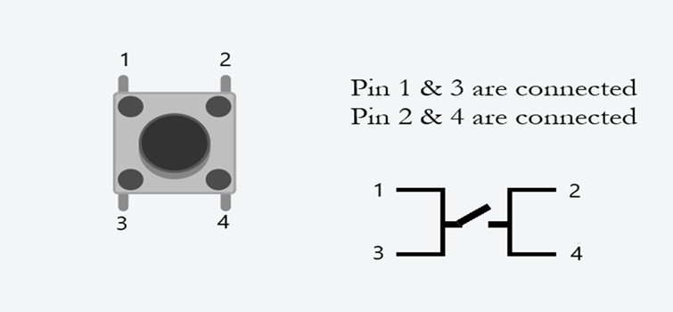

**Figure No:3.4 Button**

Connect three wires to the ESP 32 CAM board. The first two, red and black, connect to the two long vertical rows on the side of the breadboard to provide access to the 5 volt supply and ground. The third wire goes from digital pin 2 to one leg of the pushbutton. That same leg of the button connects through a pull-down resistor (here 10K ohm) to ground. The other leg of the button connects to the 5 volt supply.

When the pushbutton is open (unpressed) there is no connection between the two legs of the pushbutton, so the pin is connected to ground (through the pull-down resistor) and we read a LOW. When the button is closed (pressed), it makes a connection between its two legs, connecting the pin to 5 volts, so that we read a HIGH. In this project we are press the button once, the ESP 32 CAM module Take the Picture and send the Cloud to MIT app also send the notification to user. Android using Internet of Things (IoT) technology to monitor the status of the door, controlling the door and increasing security in a house.

**ARDUINO**

Arduino was brought into the world at the Ivrea Communication Configuration Organization as a simple device for quick prototyping, focused on understudies without a foundation in gadgets and programming. From basic 8-bit boards to products for IoT applications, wearables, 3D printing, and embedded environments, the Arduino board began to adapt to new requirements and challenges as soon as it reached a wider audience .Since all Arduino boards are open-source, users can build them on their own and eventually modify them to meet their specific requirements .The software is open-source as well, and users all over the world are contributing to its development.

For physical computing, numerous additional microcontroller platforms and microcontrollers are available. Similar features can be found in the Parallax Basic Stamp, the BX-24 from Netmedia , Phidgets , the Handyboard from MIT, and many others .The tangled complexities of microcontroller programming are encapsulated in a user-friendly package by each of these tools.

**BLOCK DIAGRAM OF PROPOSED METHOD**

Power supply for all units

ESP 32 CAM Module(AI Thinker)

Button

MIT App

12V electric lock

Take picture to cloud

Relay

**Figure No. 3.5 Block Diagram**

**4.RESULT**

In this IOT based working model, we have made a Smart WIFI door lock using ESP32-CAM and the MIT App. In this model, when someone presses the doorbell, the house owner will get a notification on the mobile with a photo of the visitor. After checking the photo, owner can unlock the door from an authenticated mobile phone.

**5. CONCLUSION**

The lock was designed to improve user convenience by allowing him to check the image of a valid visitor and opener close the door lock remotely. Another efficient system the function is that when a valid user approach, he can switch the button on art will. Now the owner doesn’t have to worry about losing the key, getting locked out, or having hands full with groceries, because the Smart Lock system has it covered. The proposed system can be commercialized into a use full product, such as a secure security system with enhanced convenience, especially when compared to existing digital door lock systems.

**6.REFERENCES**

[1]Norarzemi, Ummi Annisa, et al. "Development of Prototype Smart Door System with IoT Application." Progress in Engineering Application and

Technology 1.1 (2020): 245-256.

[2]Aldawira, Cornelio Revelivan, et al. "Door security system for home monitoring based on ESp32." Procedia Computer Science 157 (2019): 673-682.

[3]Babiuch, Marek, and Jiri Postulka. "Smart Home Monitoring System Using ESP32 Microcontrollers." Internet of Things. IntechOpen, 2020.

[4]Eethamakula, Kosalendra, et al. "Automatic Detection, Controlling and Monitoring of Temperature in Sericulture Using IOT," IJAEMA 12.8 (2020): 1099-

1103.

[5]Pavelić, Marko, et al. "Internet of things cyber security: Smart door lock system." 2018 international conference on smart systems and technologies (SST).

IEEE, 2018.

[6]Guduru, Tabu Sravani, and SURYA NARAYANA MURTHY THATAVARTHY. "IoT Based Home Monitoring System." (2019).

[7]Nascimento, David Barbosa de Alencar , and Jorge de Almeida Brito Júnior. "Application of the Internet of Things in the Development of a “Smart” Door."